

Course: VITyarthi – Build Your Own Project

Topic: Library Management System

Submitted by: Faculty:
Siya Panwar Dr. Pavithra
25bai10149 Slot: A11+A12+A13
Introduction
Welcome to the Library Management System, a beginner-friendly software crafted in python and carefully designed for smooth and reliable operation on any python-enabled computer. The main idea behind this project was to create an easy to use assistant for everyday library activities like tracking which books are available, borrowing and returning books, and keeping member records—all in one place. Using lists and dictionaries to store information, this system lets users add books, register new members, borrow or return books, and always know who has which book. The interactive menu makes each task simple to access and complete, even for someone just learning python. All data is stored only while the program runs, so each new session starts fresh, which keeps things simple and worry-free for practice and learning. This project provides a practical platform for understanding the basics of python programming, from using classes to organizing data logically. Altogether, it’s a hands on way to see how python can help keep library life organized and efficient.

Problem:
Managing a library by hand is slow, tiring, and can easily lead to mistakes, books can get lost and records can be hard to track. There is no easy way to check who has borrowed a book or which books are available, especially when the collection and member list get bigger. The goal of this project is to create a simple Python system that organizes books and members so anyone can track borrowing and returning quickly and accurately.

Objective:
The objective of this Library Management System project is to create a simple and user-friendly tool using python to help libraries organize their books and member records with ease. This system aims to automate daily tasks like adding and viewing books, registering members, and keeping track of which books are borrowed and returned. By streamlining these operations, the project helps beginners learn programming and efficiently manage small libraries using basic python concepts

Screenshots: 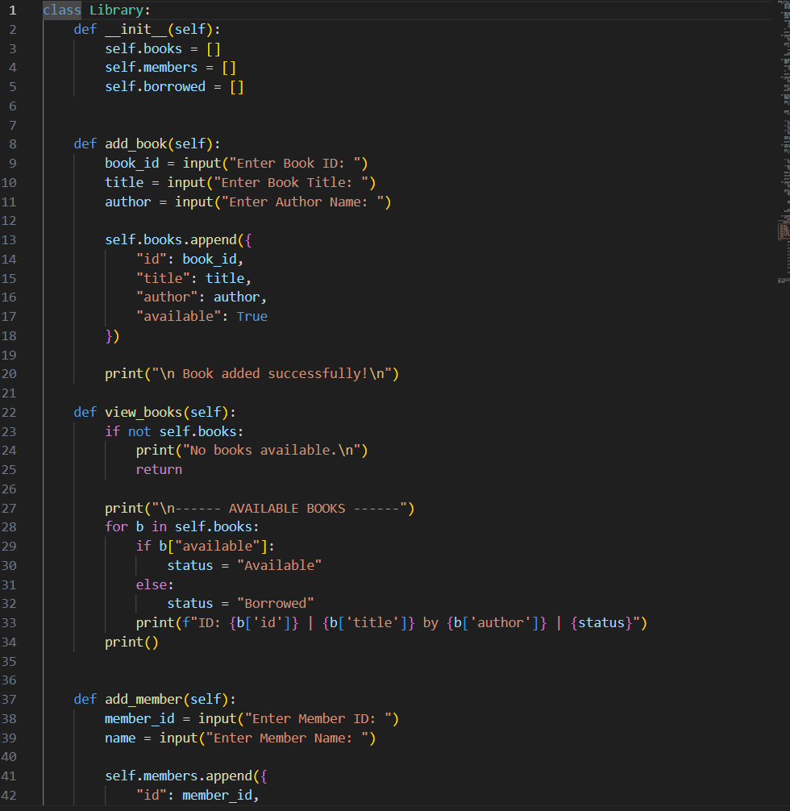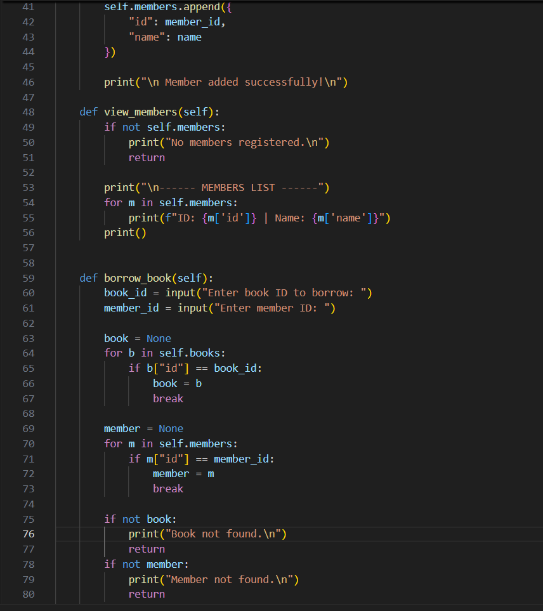
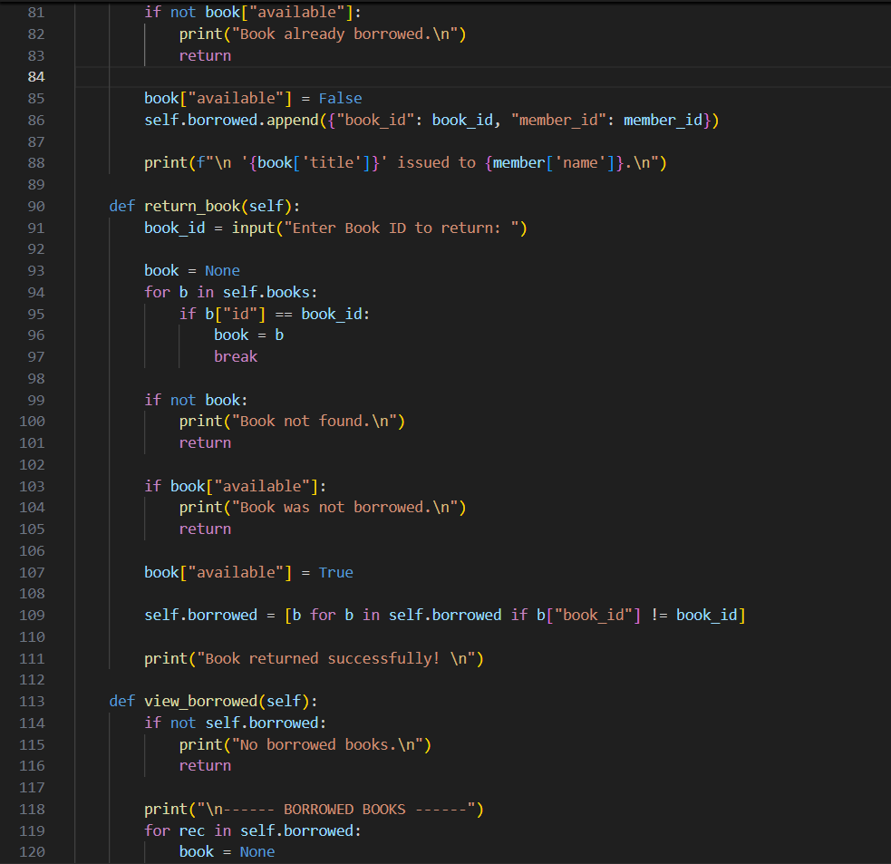
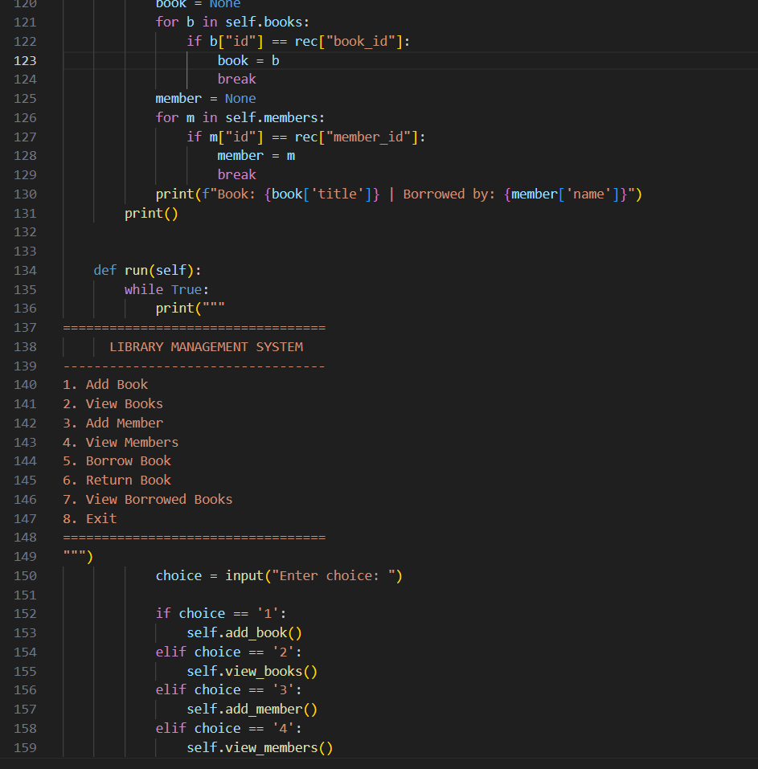

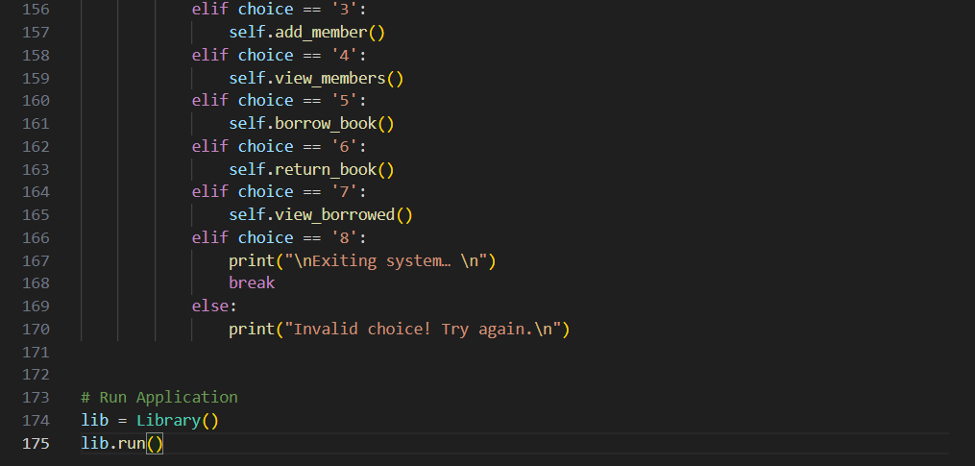

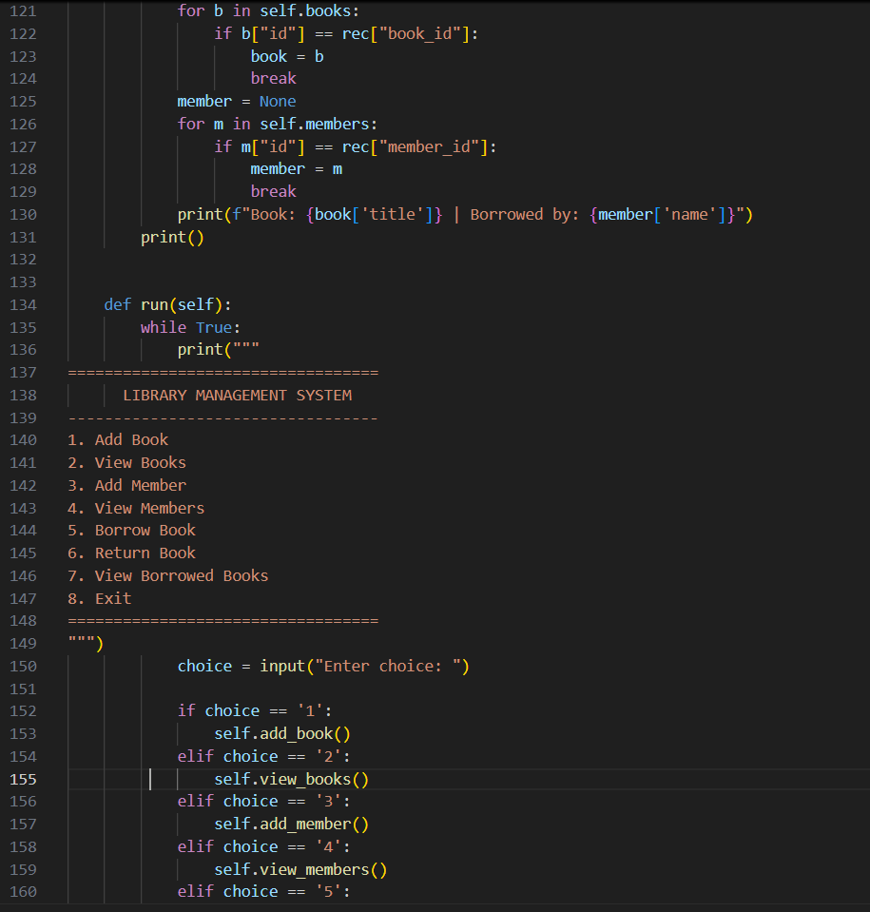

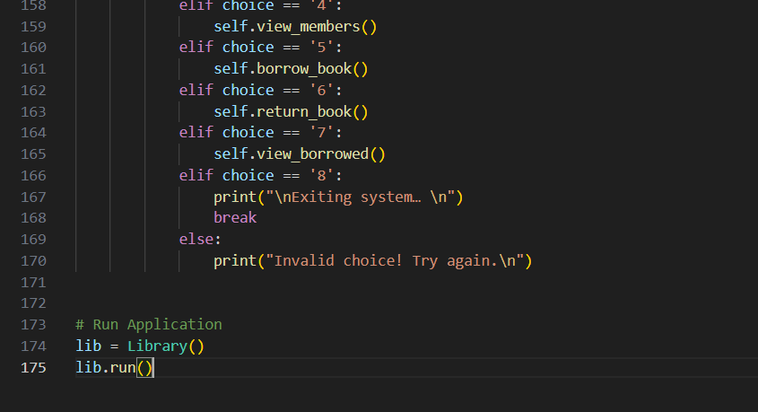

OUTPUT:
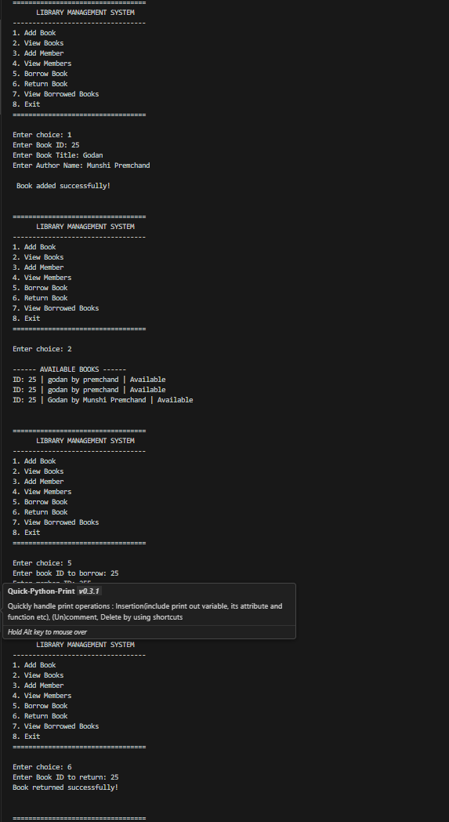

SYSTEM OVERVIEW:
The system is a simple, menu-driven Library Management System created in Python. It is built around three main elements: books, members, and borrowed records. The system lets users add new books, register members, issue books, return books, and view all current borrowings, all through an easy-to-use interface. It stores data using basic Python lists, so all records are temporary and reset each time the program closes, making it simple and ideal for learning or managing small libraries.

KEY FEATURES:
Key features include adding and viewing books, registering new members, borrowing and returning books, tracking which member has each book, and displaying all borrowed records. All data is stored temporarily using python lists, making the system easy to use and perfect for beginners or small libraries.
-Tracks checked-out books clearly
-Reduces risk of lost books
-Saves time for staff
-Reduces human errors
-Increases data accuracy
-Handles multiple users easily



